Test Report

*[Subtitle]*

[Document type]

Author:

Supervisor: [Supervisor]

Semester: HT20

Course code: 2DV610

Table of contents

No table of contents entries found.

Appendix

# Introduction

Software Development Company (SDC) aims to redistribute a simple to deploy web-server on a wide range of Internet Of Things (IOT) to present information from sensors etc. The web-server can be deployed on many different platforms and therefore that can attract attention of a wide range of IOT developers. The SDC management has found an open source abandonware software called “My Web Server” that may fulfill the requirements as stated in the requirement document. One test lead needs to deliver a strategy, plan, test-cases as well as a test-report in one week.

# Test Traceability

|  |  |  |  |  |  |  |  |
| --- | --- | --- | --- | --- | --- | --- | --- |
| **Requirements Identifiers** | **Reqs Tested** | **UC1** | **UC2** | **UC3** | **Req2** | **Req3** | **Req4** |
| **Test Cases** | 10 | 1 | 1 | 1 | 1 | 5 | 1 |
| **1 (1.1, 1.4)** | 2 | x |  |  |  | x |  |
| **2 (1.2, 1.2.a)** | 2 |  | x |  |  | x |  |
| **3 (2.1, 2.2)** | 2 |  |  | x |  | x |  |
| **4 (3.1, 3.2)** | 2 |  |  |  | x | x |  |
| **5 (Req4)** | 2 |  |  |  |  | x | x |

# Manual Tests Overview

|  |  |  |
| --- | --- | --- |
| **Test Case** | **Requirement** | **Pass / Fail** |
| TC1 | UC1, Req3 | **Pass** |
| TC2 | UC2, Req3 | **Pass** |
| TC3 | UC3, Req3 | **Pass** |
| TC4 | Req2, Req3 | **Pass** |
| TC5 | Req4, Req3 | **Fail** |

# Manual Test Cases

## Test Case 1: Start Server Successfully

**Use Case:** UC 1. Start Server

**Requirement:** Req3

**Scenario:** Starts when an administrator wants to start the server. The system starts a web server on the given port and presents that the server was started and write a note in the access log.

**Precondition:** The server is not deployed yet

**Test Steps:**

1. Set Project JDK to java “version 1.7” and Project language level to “7 – Diamonds, ARM, multi-catch etc”.
2. Edit Configuration for the class “HTTPServerConsole”, and set Program Arguments as “9000 C:/Github/Repository/2DV610/MyWebServer-master/bin/se/lnu/http/resources/inner/”.
3. In terminal enter “ java se.lnu.http.HTTPServerConsole 9000 ~/MyWebServer-master/bin/se/lnu/http/resources/inner/”.
4. In web broser enter “localhost:9000”.

**Expected Results:**

Web browser:

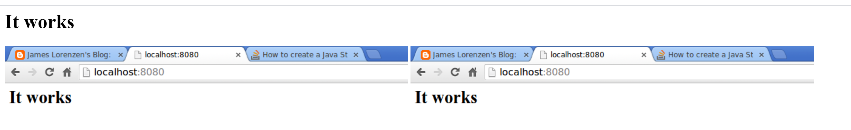

Console:

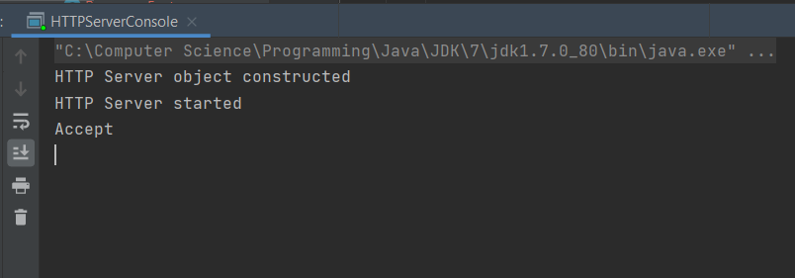

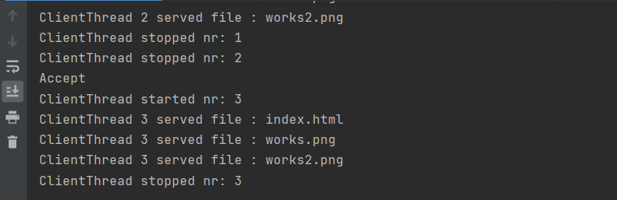

**Actual Results:** **Pass**

## Test Case 2: Start Server with Taken Socket Port Number

**Use Case:** UC 1.2. Start Server

**Requirement:** Req3

**Scenario:** System asks for socket port number and shared resource container. The web server could not be started due to the socket was taken.

**Precondition:** The server is not deployed yet

**Test Steps:**

1. Set Project JDK to java “version 1.7” and Project language level to “7 – Diamonds, ARM, multi-catch etc”.
2. Edit Configuration for the class “HTTPServerConsole”, and set Program Arguments as “80 C:/Github/Repository/2DV610/MyWebServer-master/bin/se/lnu/http/resources/inner/”.
3. In terminal enter “ java se.lnu.http.HTTPServerConsole 80 ~/MyWebServer-master/bin/se/lnu/http/resources/inner/”.
4. In web broser enter “localhost:80”.

**Expected Results:**

Console:

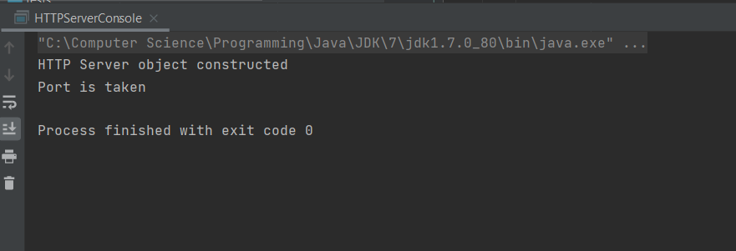

**Actual Results:** **Pass**

## Test Case 3: Stop Server Successfully

**Use Case:** UC 2. Stop Server

**Requirement:** Req3

**Scenario:**

1. Starts when a user wants to stop the server.
2. The system stops the web server and presents that the webserver has been stopped.

**Precondition:** A web server has been started.

**Test Steps:**

1. Type “stop” in the console.
2. Navigate to web server.

**Expected Results:**

Web browser:

 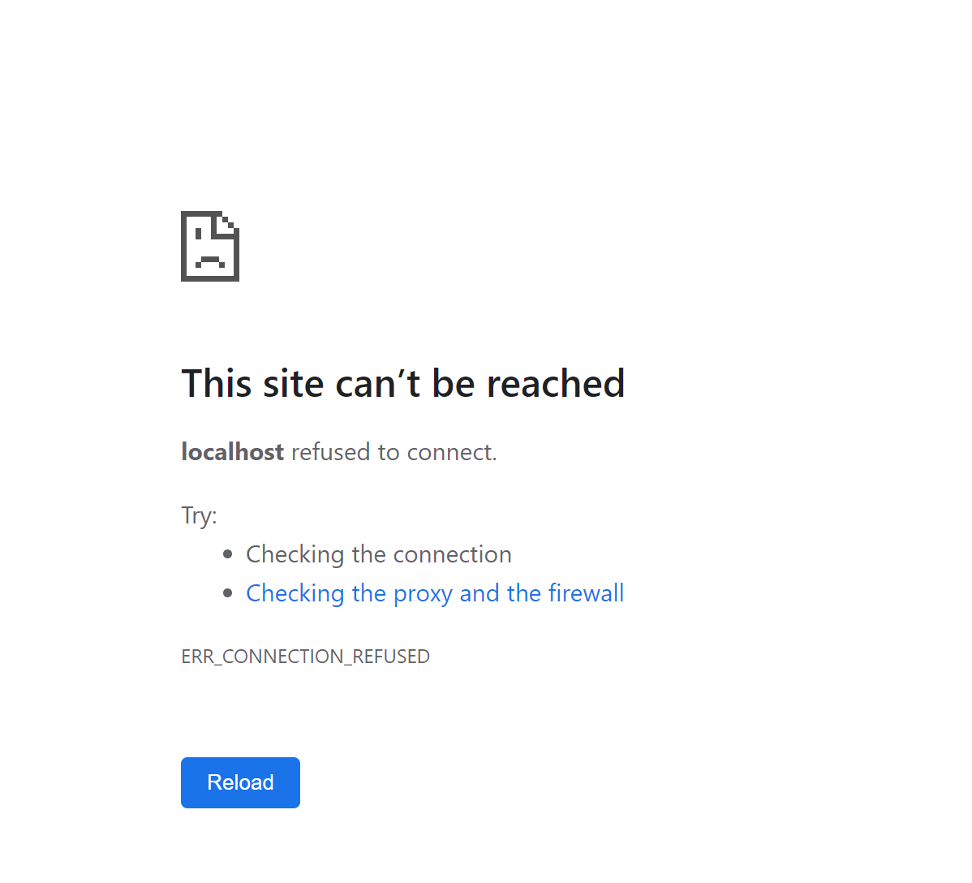

Console:

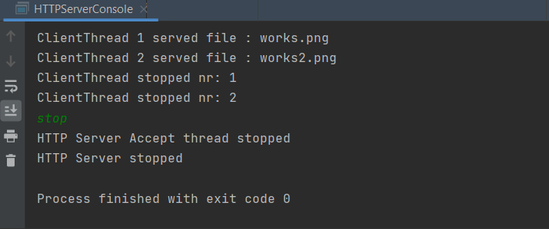

**Actual Results:** **Pass**

## Test Case 4: Request Shared Resource Not Found

**Use Case:** UC 3. Request Shared Resource

**Requirement:** Req2, Req3

**Scenario:** The system delivers the shared resource to the browser and a success message is written to the access log. The shared resource cannot be found.

**Precondition:** A web server has been started.

**Test Steps:**

1. Remove the secret.html file.
2. Navigate to web server.

**Expected Results:**

Web browser:



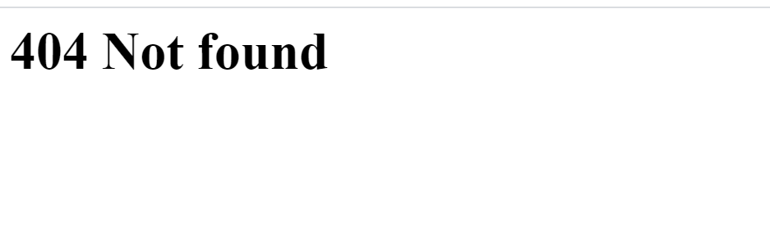

Console:

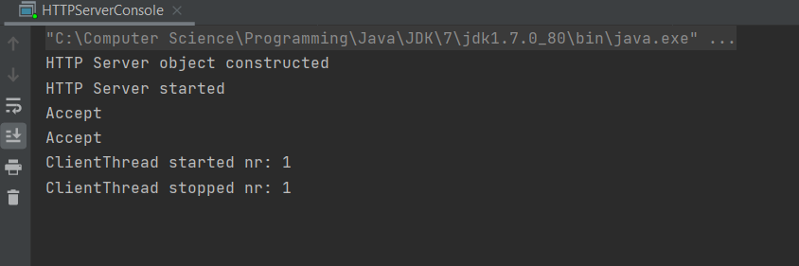

**Actual Results:** **Pass**

## Test Case 5: GPL-2.0

**Requirement:** Req4

**Scenario:** The source code should be released under GPL-2.0

**Precondition:** A web server has been started.

**Test Steps:**

1. Check LICENSE file.

**Expected Results:**

GPL-2.0 (General Public License, version 2)

**Actual Results:** **Fail**

MIT (Massachusetts Institute of Technology License)

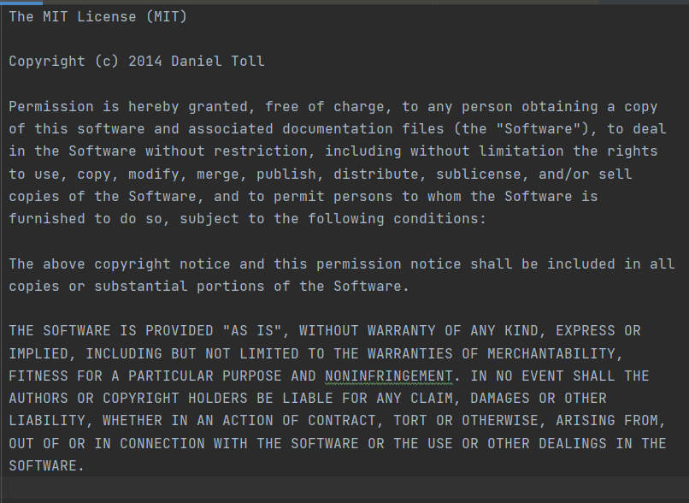

# JUnit Tests

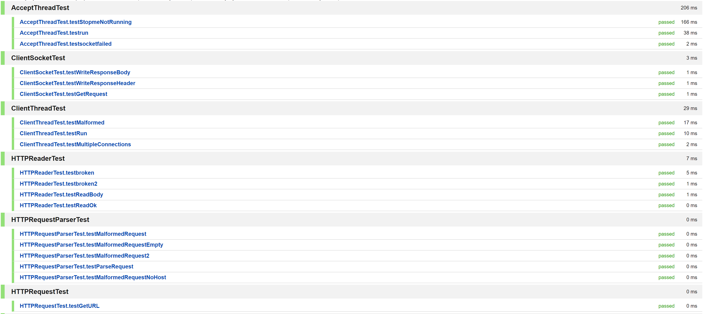

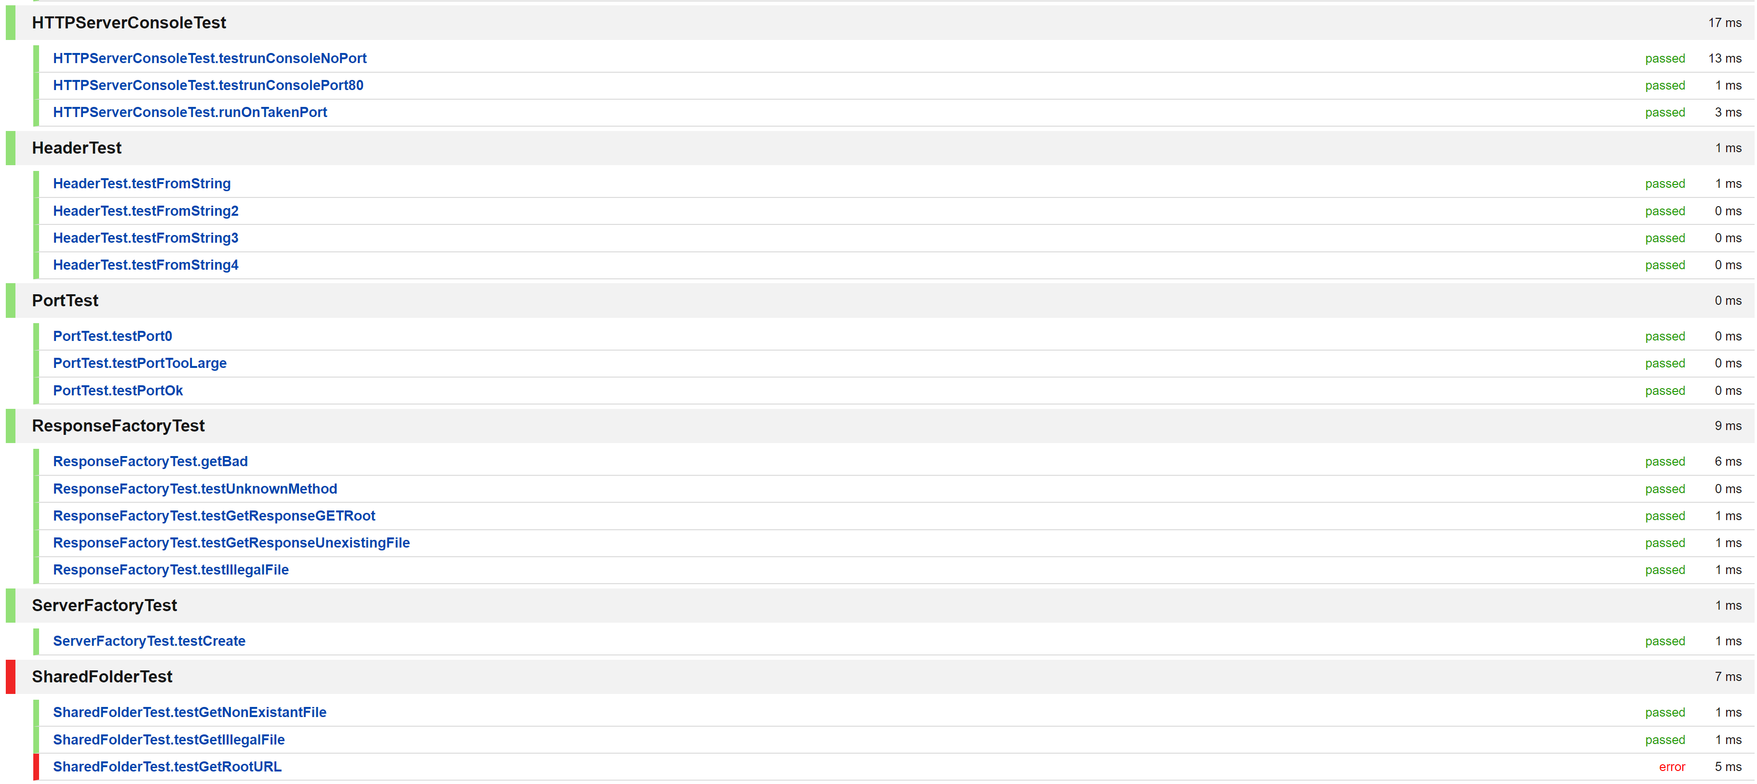

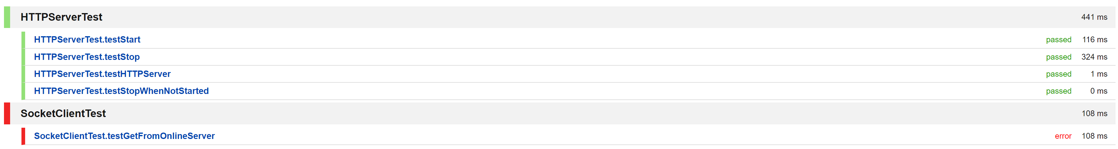



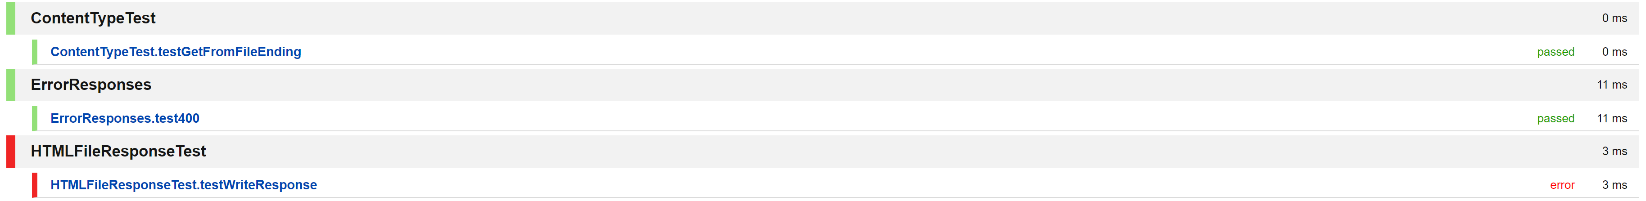



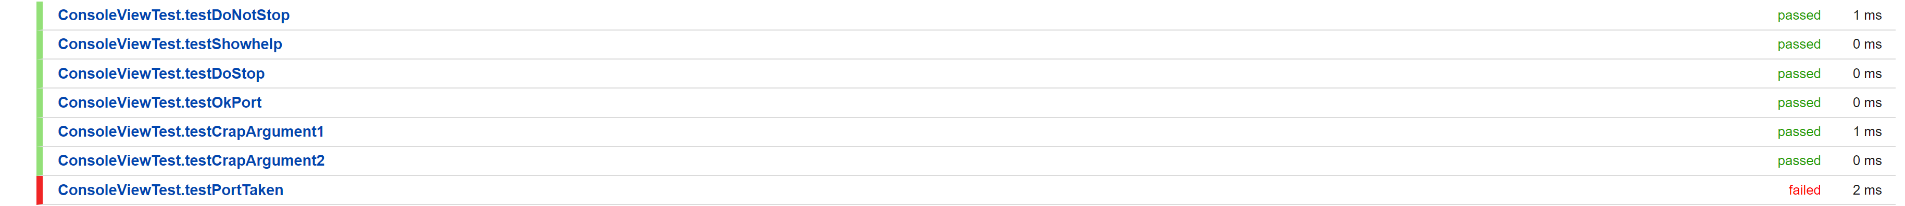

# Resources

|  |  |
| --- | --- |
| **Resource Type** | **Resource** |
| Staff | 1 Test Lead |
| Time | At Least 20 Hours |
| Equipment | Windows 10 Home with Processor Intel® Core™ i7-10519U CPU @ 1.80GHz 2.30 GHz |
| Software | IntelliJ IDEA 2020.3  JDK: Java Version 1.7  Web-Browser: Chrome  JUnit  Apache JMeter |

# Conclusion

During testing process, the manual testing resulted in more failed tests than the result. Because some of the test cases are combined, therefore, they do not present the precise result. The source code is not released under GPL-2.0 but actually having a MIT License.